***Technical Document:***

**Title: SLAM ZE500 Printer Firmware update to SP53-004402C.zpl**

**Site: RME Central Services (AE)**

**Name:** Jesse Yearta, JYEARTA@

**Date:** 20200215

**MCM Number:** <https://mcm.amazon.com/cms/MCM-52955915>

**SIM Number**: <https://issues.amazon.com/issues/OpsTechITCert-56>

**PCA:**

# Current standing

SLAM ZE500 Print engines are running V53.17.18Z, Current approved and tested version is SP53-004402C

## Business Need

New Firmware is a custom development with amazon and zebra industries some features based of Smart pack firmware. Including security vulnerability fixes with performance improvements. One of the new features will allow the engine to rotate the label for improved read on the verify system. Review MCM and SIM for details on rotation testing.

<https://mcm.amazon.com/cms/MCM-38685230> Pilot Site MCM. Trialing the new firmware.

# Proposed Solution

## Summary Overview

Each site will perform firmware update on there SLAM ZE500 print engines. By flashing new firmware to the controller.

## Engineering Overview

***.***

1. Firmware change long release details **Release Details**
   1. **Customer Name:** Amazon
   2. **Special Numbers:** SP53-004402B
   3. **Based On Version:** SP53-004402A / V53.17.22ZB
   4. **Printer:** ZMx00, Xi4, ZE500 (V53)
   5. **Full Release Summary Description:**

Custom firmware for Amazon's V53 printers.

Rev A:

* + 1. Add TLS raw socket server.
    2. Add SNTP client to update current date and time.

Rev B:

* + 1. Support 2 concurrent TLS connections.
    2. Add ROTATION MODE.
    3. Security Patches.

# Risk

## What are the risks?

Firmware flashing process could render unit inoperable. Settings are not backed up and require manual dial in of the print engine.

## How to mitigate those risks

Backup all setting for you print engine, Have current firmware copy on hand incase of need to roll back and flash down.

Site will perform the flashing of 1 SLAM line for verification and run check to ensure no issues come about. Site will only perform this firmware flashing after verifying they have a replacement engine incase the unit becomes inoperable. After initial test site will flash each engine, validate changes and operation of SLAM before flashing next engine. Please also have the current version of you ZE500 on hand for need to roll back.

# Other Options Considered

## List Other Options

None

# Expected Outcome

## Define “Success”

Print engine firmware will be set to SP53-004402CS, SLAM restore to normal operating mode. Label rotation function will be present alone with Security and vulnerability fixes

## Define “Complete”

Engine returned to operation and processing packages as intented.

# Resources

## Labor

Site CSX

***Software Change: 1 man hour***

## Parts

USB cable A to B, Zdownloader software will be needed to flash new firmware, firmware that is currently in the machine for roll back, and new firmware.

All software can be sourced <https://policy.amazon.com/procedure/1927> near bottom of page:

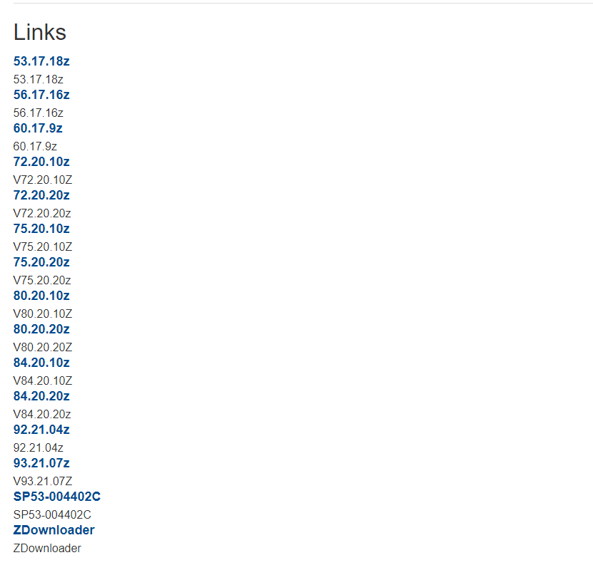

Instructions for Flashing firmware are also located on the Policy Site.

Copy included in this Technical Document.

***Simple STEP list.***

***STEP1. Have copy of your current firmware on hand from Policy Site***

***STEP2. Have Z downloader installed on your laptop***

***STEP3. Have USB a to b cable on hand***

***STEP5. Backup ALL print engine settings***

***STEP6. Flash firmware of ZE500***

***STEP7. Validate flashing. ZE500 will display current version***

***STEP8. Load Print engine settings***

***STEP9. Validate the SLAM operates normally in auto slam mode.***

***STEP10. Repeat step on each print engine on all of you SLAM lines***

**STEP00. Some sites have IT managed print engines? Please verify which firmware are on these units, if they are not upto date engage you local IT for these managed auto SLAM zebra print engines to have a plan of action.**

Helpful Links:



Network MCM for roll out:

<https://mcm.amazon.com/cms/MCM-52955915>

Pilot Site:

<https://mcm.amazon.com/cms/MCM-38685230>

*OpsTech IT update Policy Page, Software and firmware’s can be source here at bottom of page:*

<https://policy.amazon.com/procedure/1927>

SIM relating to firmware update:

<https://issues.amazon.com/issues/OpsTechITCert-56>

**Install zdownloader.exe**

1. Double-click on the zdownloader-300.exe file.
2. Enter your AD account credentials if prompted for them, and click "Next" through all of the installation windows.
3. After the installation is complete, click the "Finish" button and restart your laptop. Zdownloader is now installed on your laptop and ready for use.

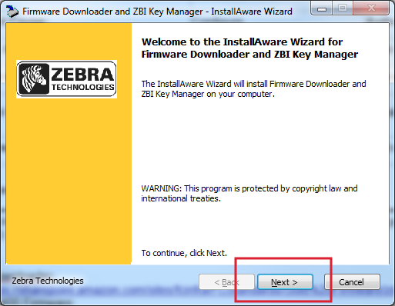

[4.](https://grc.amazon.com/docs/draft/1927#s4.)

**Connect Printer**

1. Connect the ZM400 to a USB port on your laptop.
2. Open the Zdownloader software by clicking on the Windows Start menu, typing "Firmware" into the search bar, and then clicking "FirmwareDownloader".

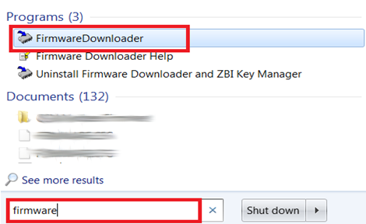

[5.](https://grc.amazon.com/docs/draft/1927#s5.)

**Associate Printer over USB**

1. Click on the "Auto-Detect Printers" icon in the upper left-hand corner of the window.
2. If you receive a Windows Firewall Exception warning, just cancel the pop-up.

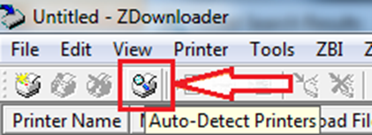

[5.1](https://grc.amazon.com/docs/draft/1927#s5.1)

**Associate Printer over Network**

Click on the menu bar Printer and then Add

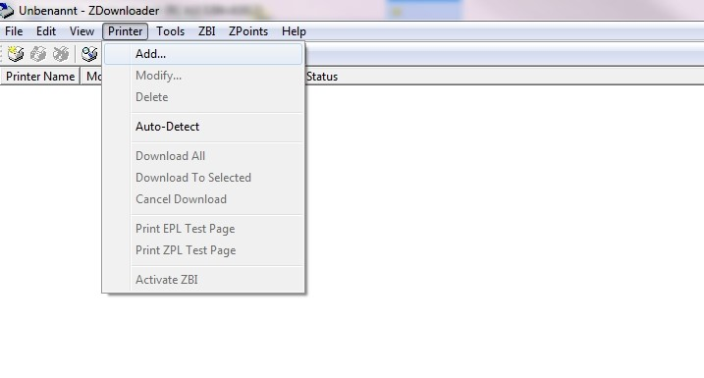

[5.2](https://grc.amazon.com/docs/draft/1927#s5.2)

It will open the printer settings

Printer Name:                        This field is only a overview and is not important

Printer Model:                        This field is only a overview and is not important

Communication Type:           You can choose between Network, Parallel and Serial

TCP/IP Address:                   Enter the IP Address of your printer

              (Only for Communication Type: Network)

Port:                                        It must be set the **5964**

              (Only for Communication Type: Network)

When all fields are filled, press "OK"

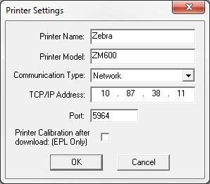

[6.](https://grc.amazon.com/docs/draft/1927#s6.)

**Expected Outcome**

A printer object will now be visible in the main window.

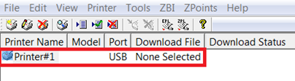

[7.](https://grc.amazon.com/docs/draft/1927#s7.)

**Install Firmware**

Right-click on the printer object and click "Select Firmware File..."

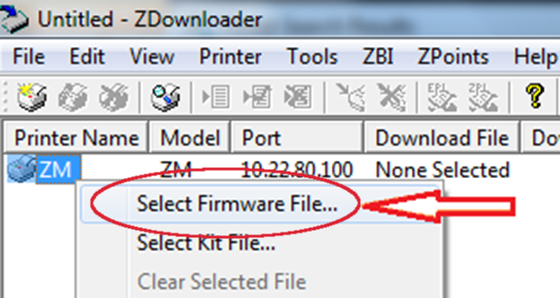

[8.](https://grc.amazon.com/docs/draft/1927#s8.)

**Locate Desired Firmware File**

Browse to the location where you saved the firmware file you downloaded earlier and select "Open".

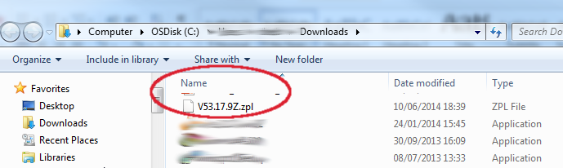

[9.](https://grc.amazon.com/docs/draft/1927#s9.)

**Download Firmware to Printer**

Right-click on the printer object again and click "Download to Selected".

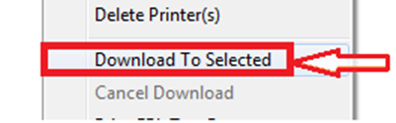

[10.](https://grc.amazon.com/docs/draft/1927#s10.)

**Monitor Download Status**

1. A Download Status progress bar will turn blue showing the file transfer. You must allow the progress bar to reach 100% for the download to be complete.
2. After the transfer finishes, the printer will apply the new firmware and then power cycle.

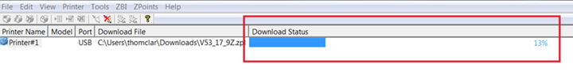

[11.](https://grc.amazon.com/docs/draft/1927#s11.)

**Confirm Firmware Version**

The ZM400/600 will display its firmware version number on its display screen. Confirm that the version number presented matches the firmware that you installed. For example, Version V53.17.15 is shown below